P1
RE: Reflectance Edges
TE: Texture Edges
HE: Highlight Edges
SE: Shadow Edge
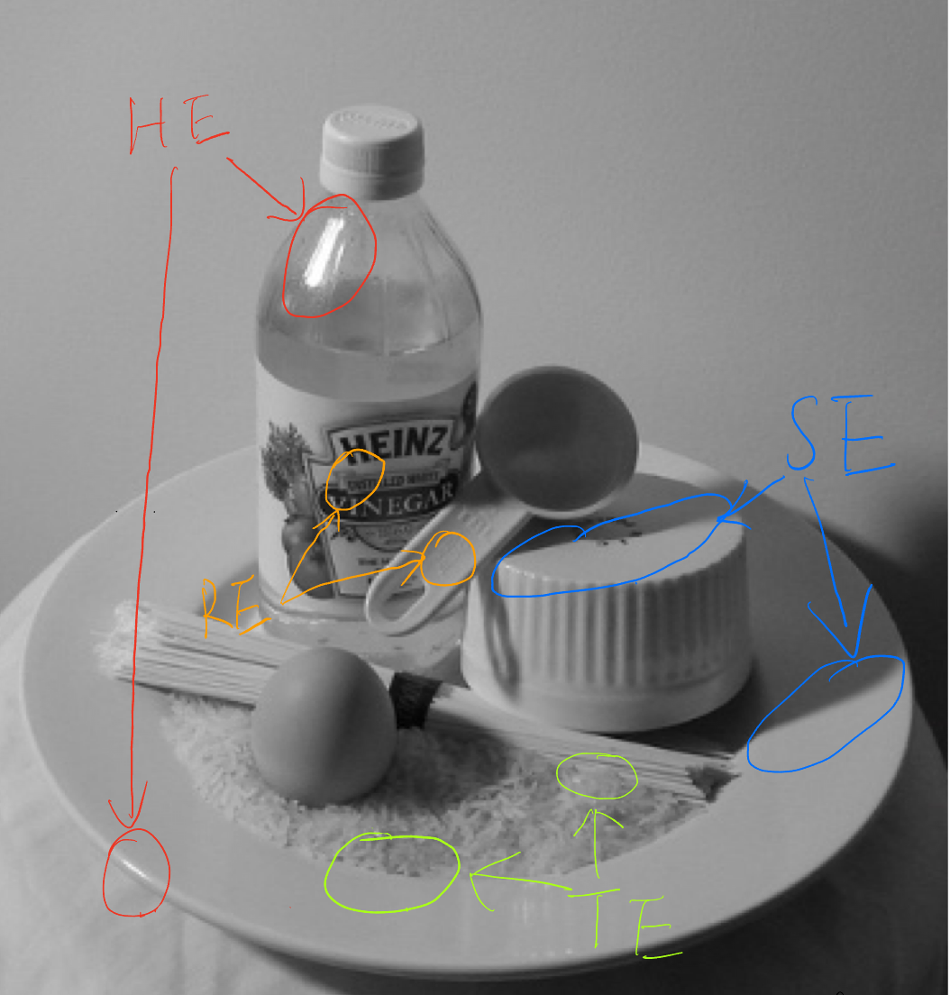
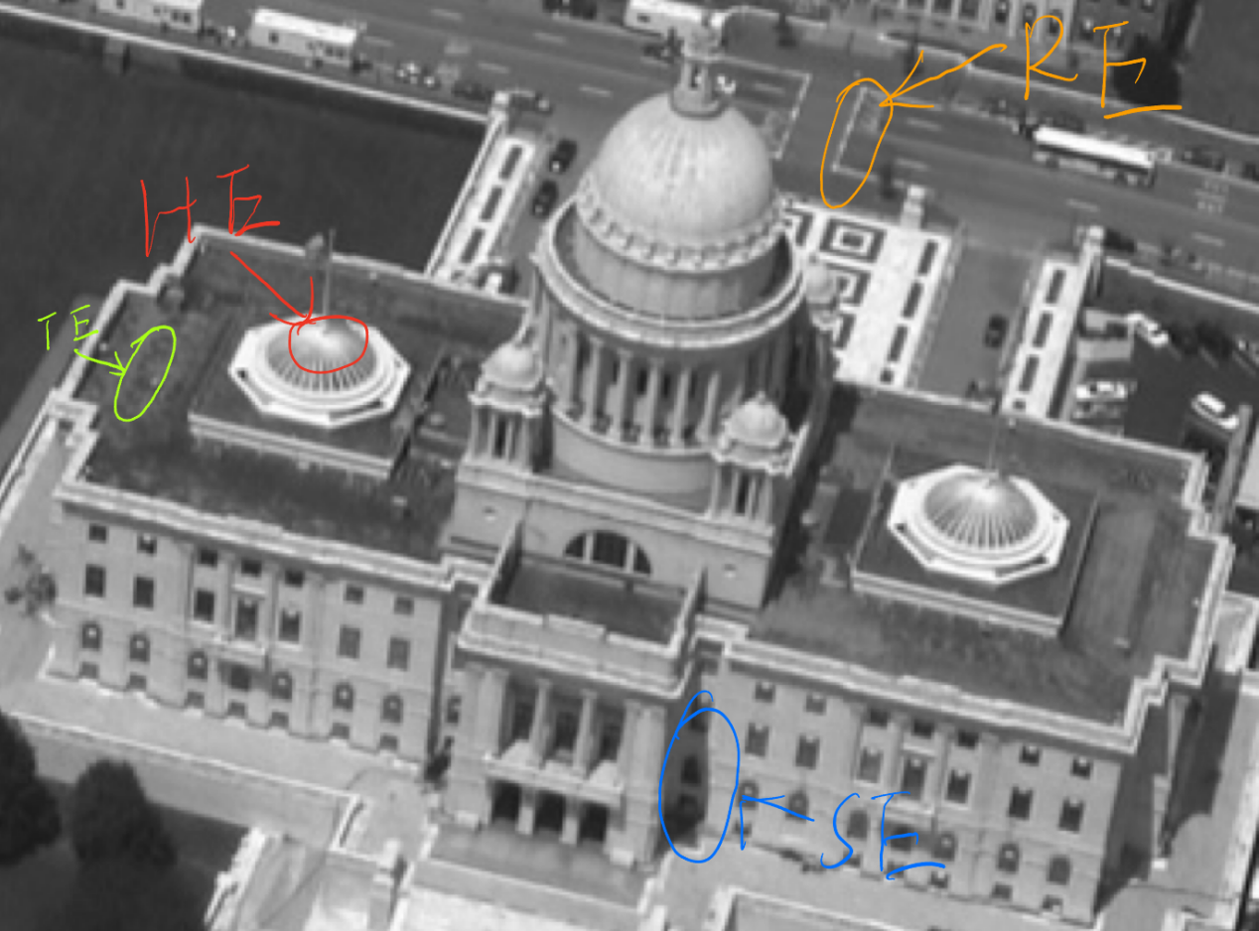

P2
- Threshold: 10
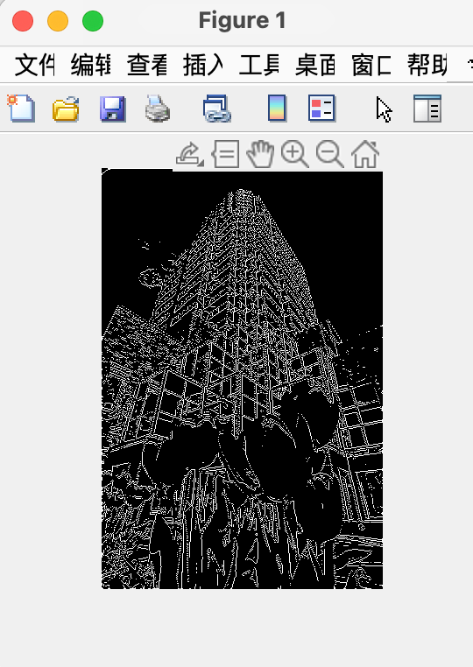

- Threshold: 12
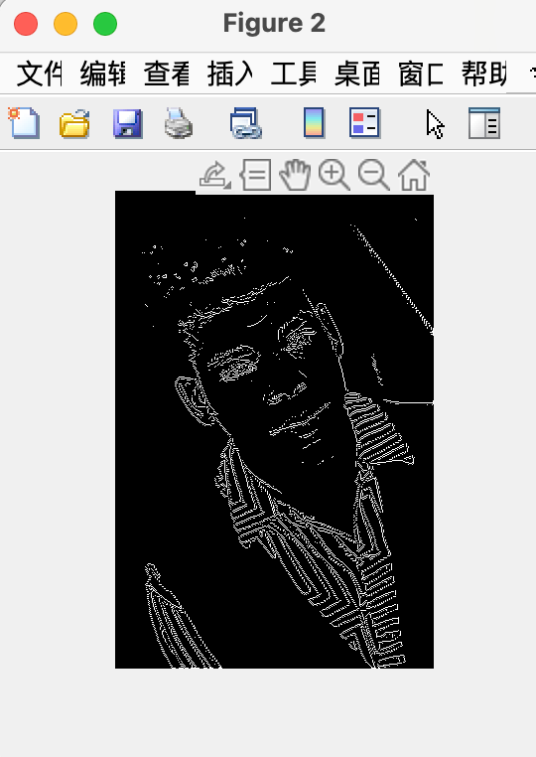

- Threshold: 15
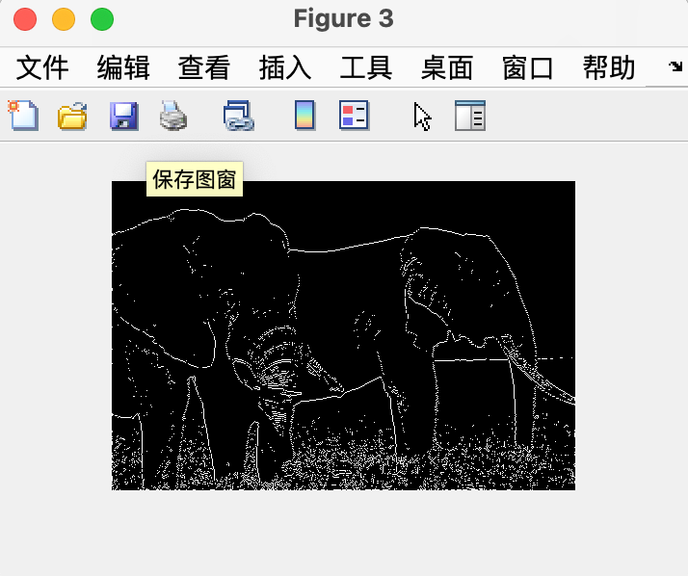
- Threshold: 20
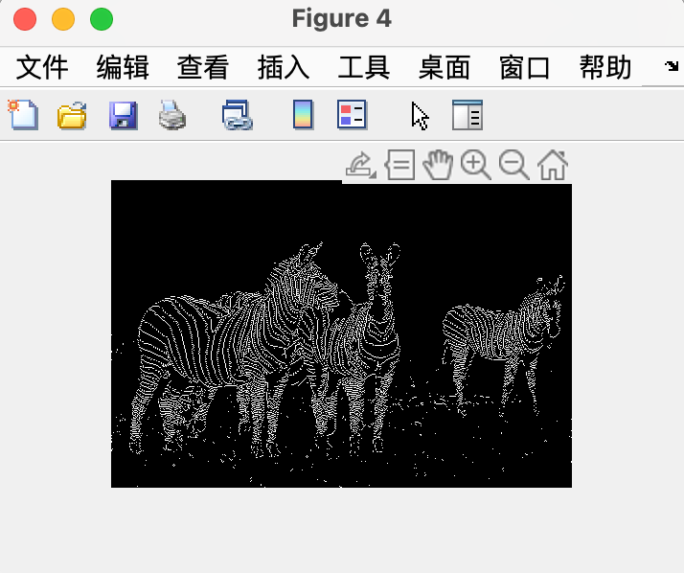

- Threshold: 30
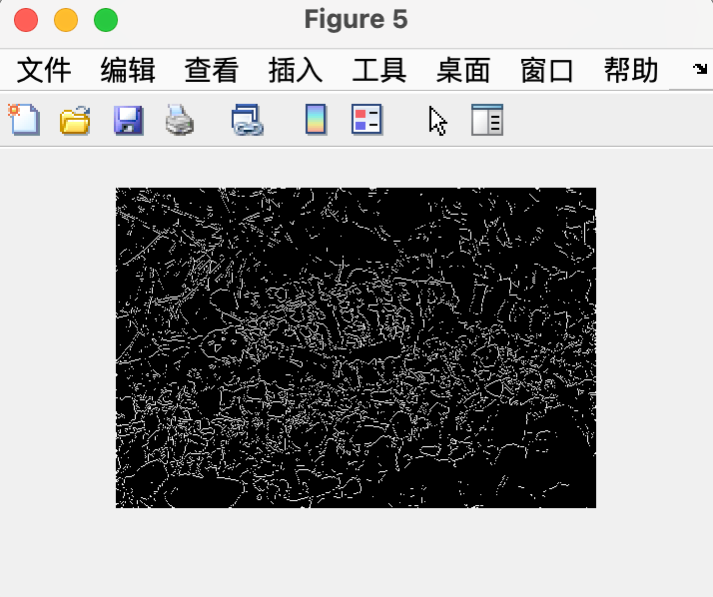

- Threshold: 23
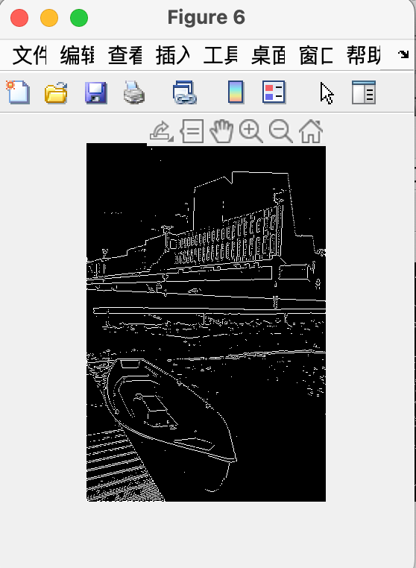

P3
- Strengths of Canny: It is better at corners, curved edges, and noise inclusion/exclusion.
- Weaknesses of Canny: It is less sensitive to intensity change edges than my P2 algorithm. And Canny always take more time to do the edge detection.
- Two thresholds: [0.1 0.2] & Gaussian sigma: 0.5
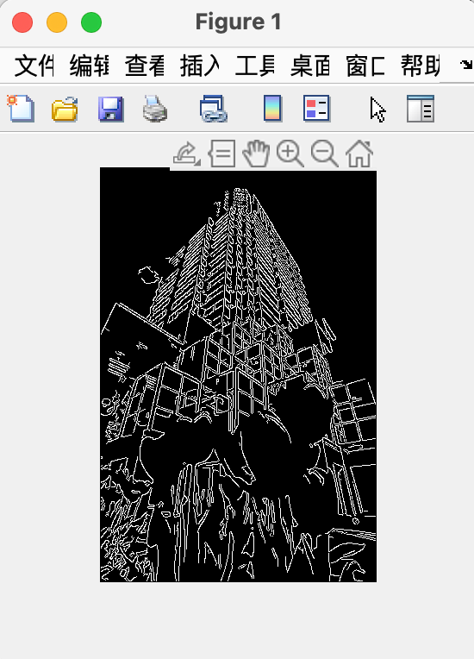
- Two thresholds: [0.1 0.2] & Gaussian sigma: 0.5
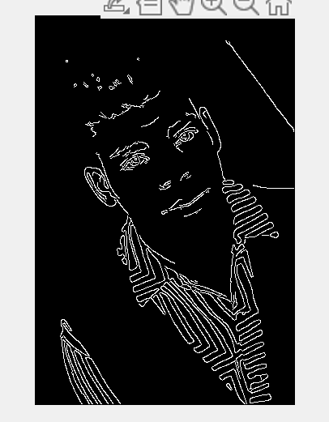
- Two thresholds: [0.1 0.2] & Gaussian sigma: 0.5
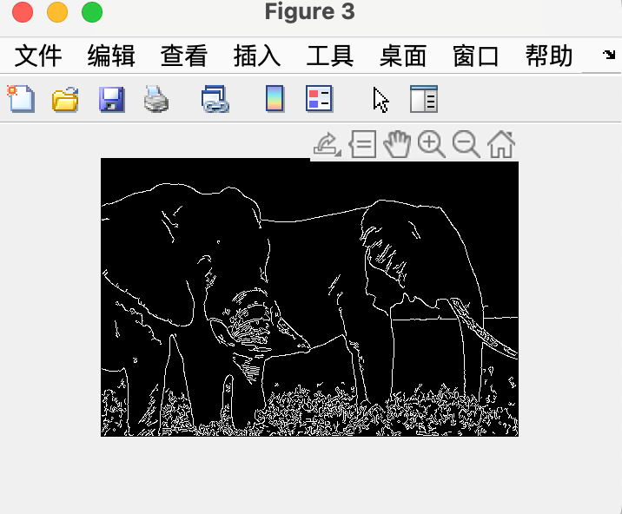

- Two thresholds: [0.1 0.2] & Gaussian sigma: 0.5
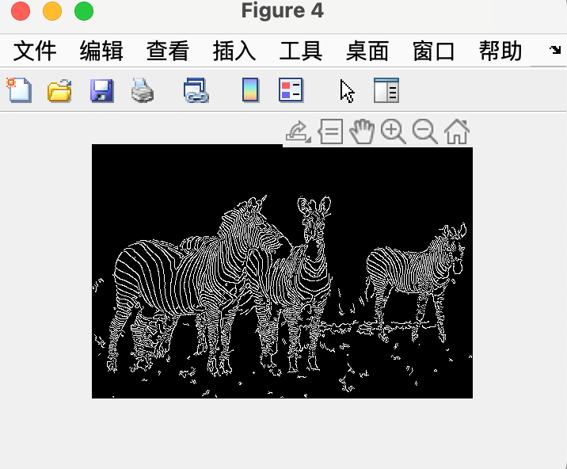
- Two thresholds: [0.2 0.3] & Gaussian sigma: 0.5
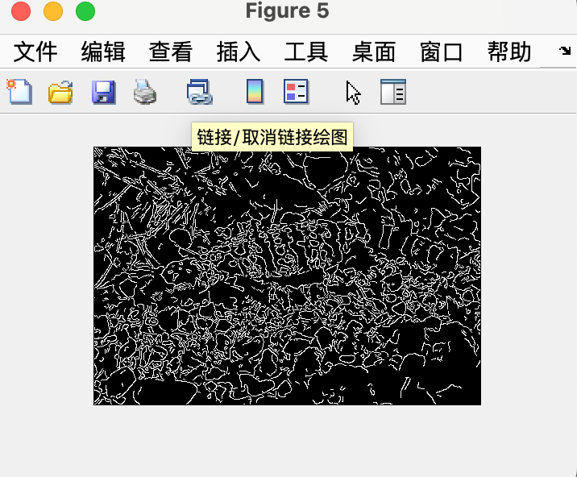
- Two thresholds: [0.1 0.2] & Gaussian sigma: 0.5
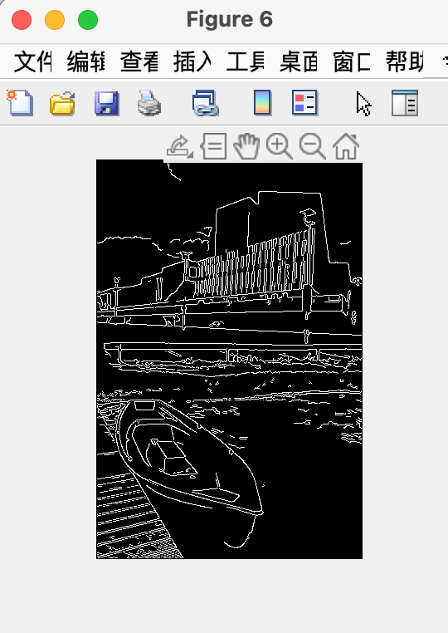
- The detection of intensity edges, which are characterized by abrupt changes in pixel intensity or color within an image, is best accomplished using canny edge detection. The sharp transitions in the image, such as the edges of objects or structural elements, are often represented by these edges. The Canny edge detection technique is well-suited for detecting intensity edges since they are the most prevalent and simple sort of edge in many photos. The Canny approach may not be as effective at capturing other sorts of edges, such as texture, highlight, shadow, and reflectance edges, which are frequently more complex.
For example, in the diagram below. In the red circle is the texture edges, It is not be capturing by the algorithm. However, Most intensity edges is captured by the algorithm, like the edges in blue circle.
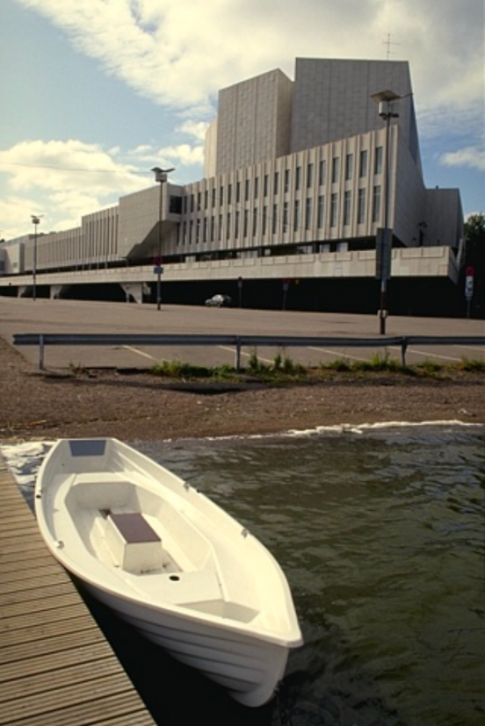

P4
I think 8 oritations, 16 bins and a 5-radius circle is the best choice:
below is my output images:
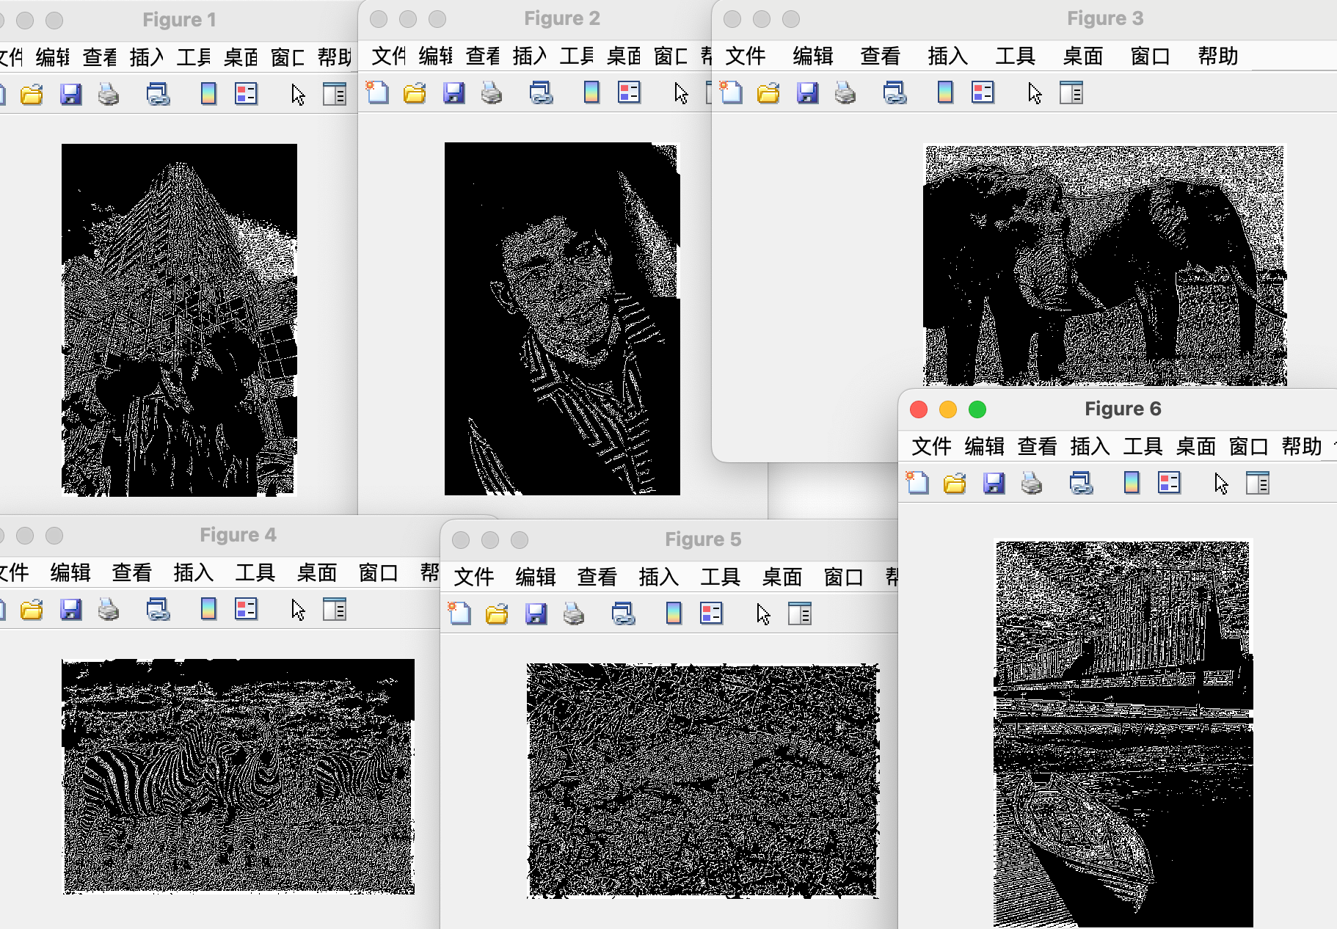

P5
Belwo is my binary edge maps:
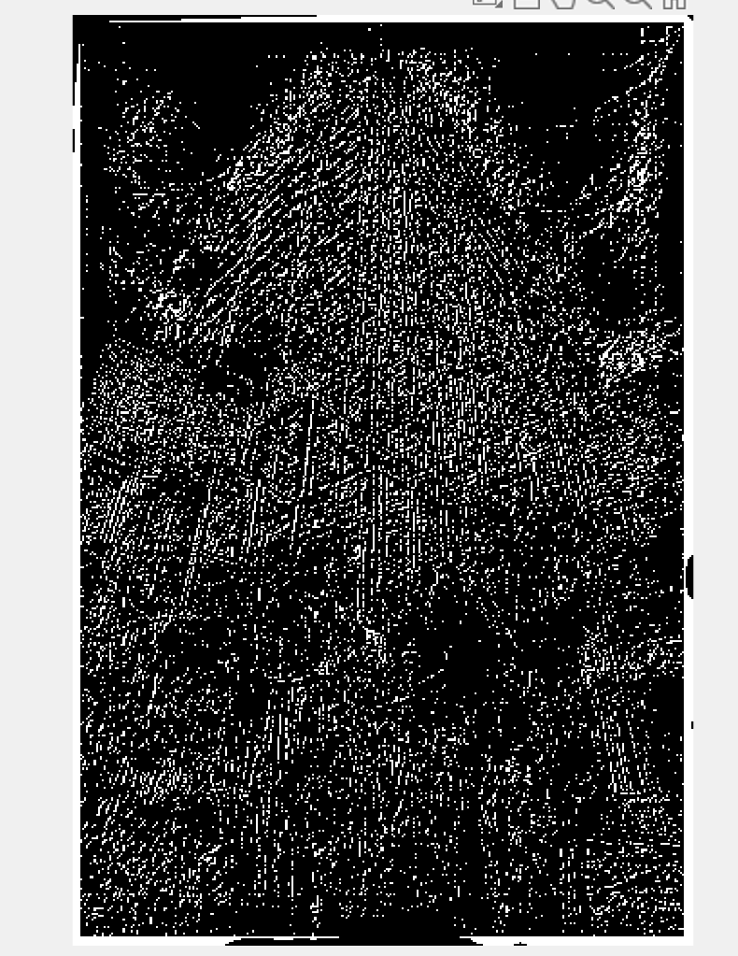

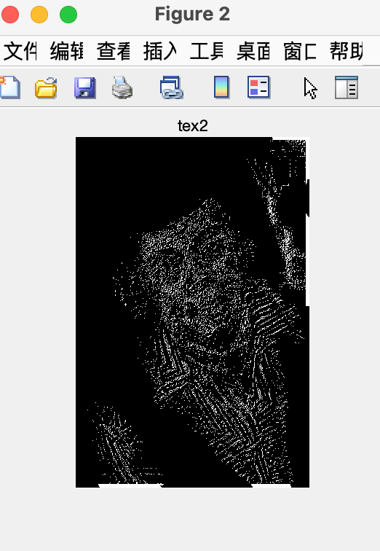
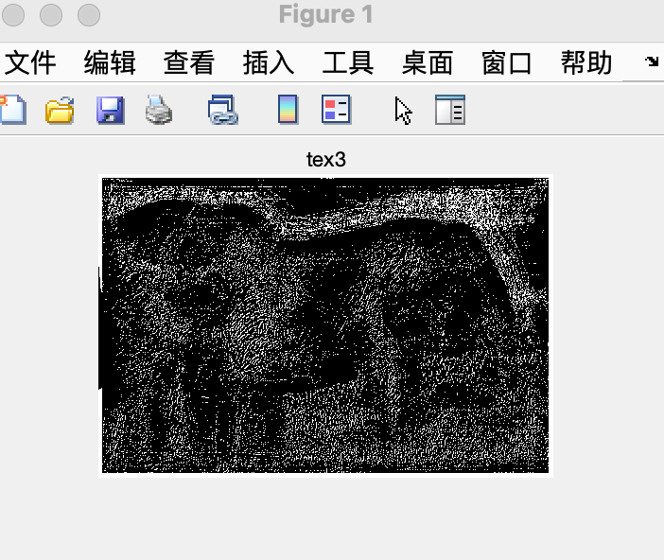

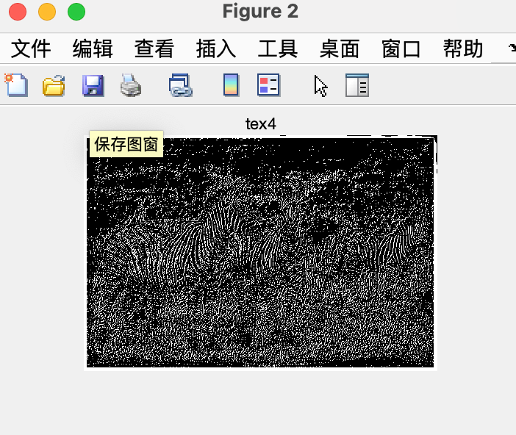

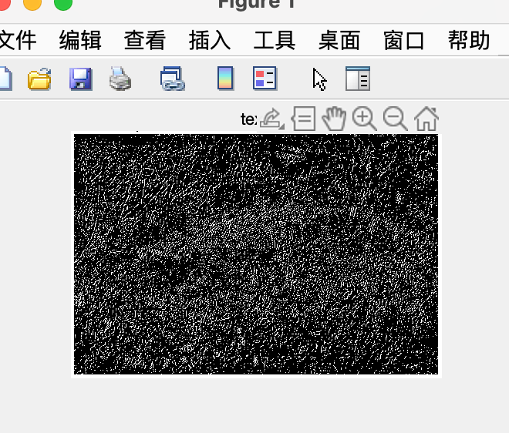

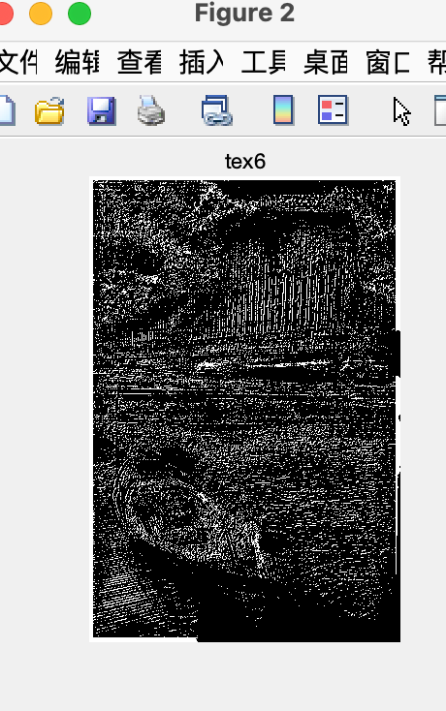

P6
Here is the final binary edge map :
The left is Image with high threshold, middle is image with two threshold, on the right is Image with low threshold.
